DSA0502 QUERY PROCESSING FOR DATASCIENCE
CO1 – AT1 – DATA INTERPRETATION

Que:28.Agriculture Crop Yield Analysis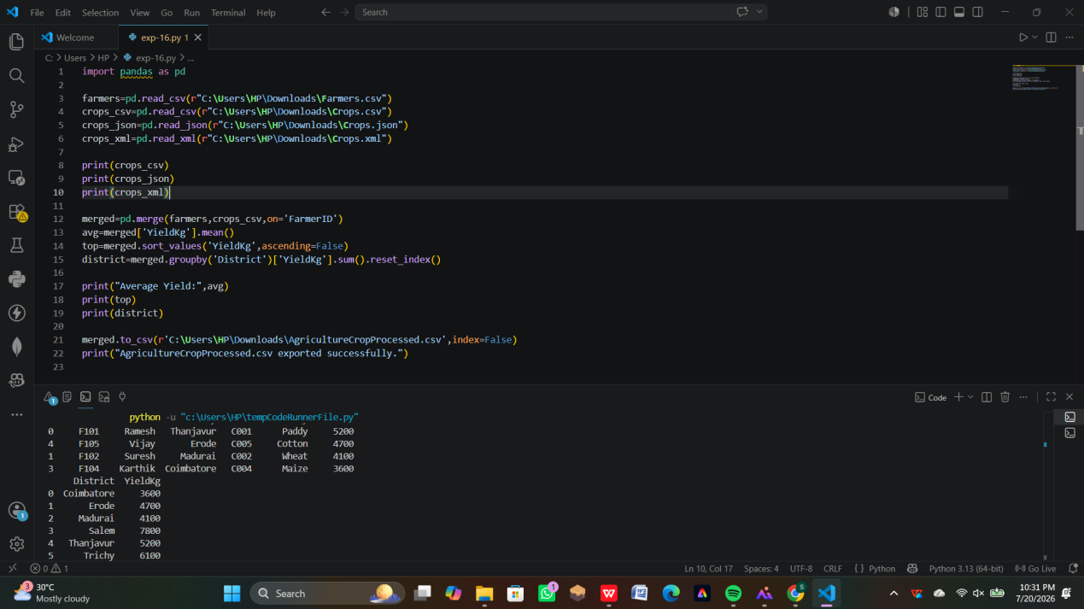

Que:28. Movie Ratings
